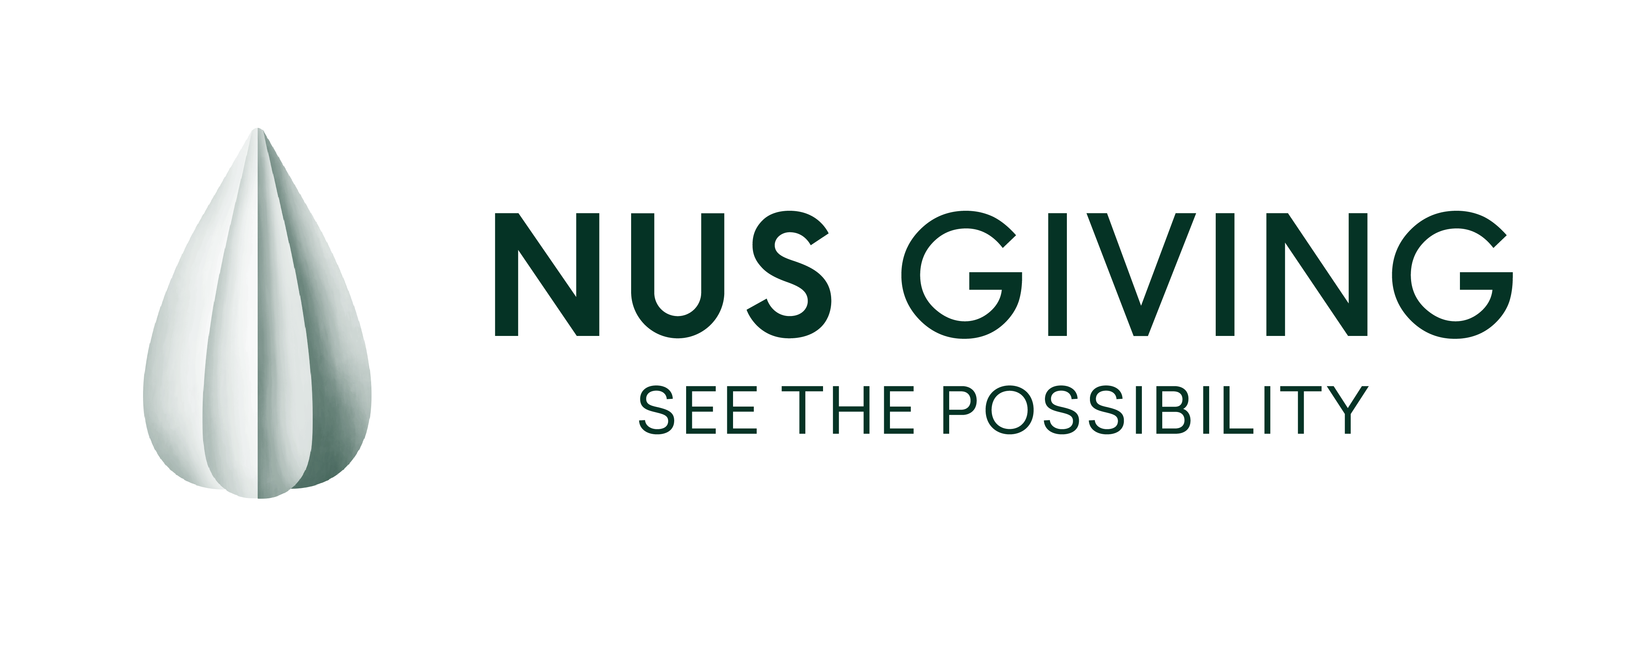
Please send the completed form to
Lee Kong Chian Natural History Museum.

Gift Form | Individual Donor

By mail:

By email:

Ms Doris How
National University of Singapore
Lee Kong Chian Natural History Museum
2 Conservatory Drive, Singapore 117377

dorishow@nus.edu.sg

Yes! I want to support: Singapore Baleen Whale Project

One-Time Gift:
☐ S$1,000
☐ S$5,000
☐ I want to make a one-time gift of S$______________

Multi-Year Gift:
☐ S$10,000/year over 3 years*
☐ S$50,000/year over 3 years*
☐ I want to make a gift of S$______________/year over __________ years*
*I authorise the University to continue deducting my yearly gift from the credit/ debit card indicated in this form, including any replacement card thereof issued to me, until written termination is received from me.

GIFT FULFILMENT (Please tick one.)
☐ Credit / Debit card (Visa / MasterCard /AMEX):

Card No.: - - -

Expiry Date: / (MM/YY)

☐ Cheque [No.: ] crossed and made out in favour of ‘National University of Singapore’

☐ Cash

☐ Bank Transfer
Beneficiary’s Name: | National University of Singapore
Account No.: | 032-000313-3
Beneficiary’s Bank: | DBS Bank Ltd, Singapore
Bank Address: | 12 Marina Boulevard DBS Asia Central, Marina Bay Financial Centre Tower 3  Singapore 018982
SWIFT Code: | DBSSSGSG

MY PARTICULARS

Name: (☐Prof / ☐Dr / ☐Mr / ☐Mrs / ☐Ms) _______________________________ _______________________________________
(Family Name) (Given Name)

NRIC/FIN in full: Contact Number: _______________________________
(Required for auto-inclusion of tax deduction to IRAS. Singapore tax residents are eligible for a tax deduction 2.5 times the gift value for gifts received by NUS)

Email Address: Gift Remarks: __________________________________

☐ I do not wish to be identified as the donor of this gift in NUS publicity materials.

Signature of Donor / Date:
I agree that my gift is subject to NUS’ Statutes and Regulations, and to its Standard Terms and Conditions for Gifts (as may be amended from time to time by the University), updated for compliance with the Personal Data Protection Act 2012.

